Square
Rectangle
Triangle
Parallelogram
Rhombus
Trapezium
Kite
Circle
Sector

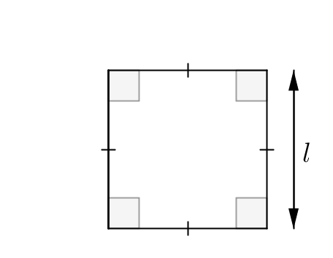  Formula: |   5m
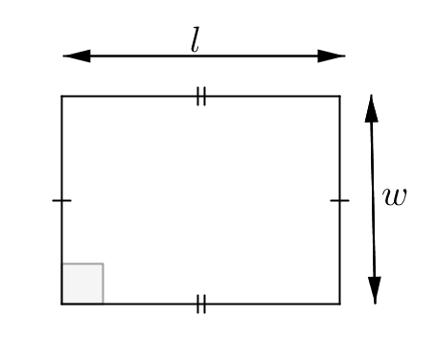  Formula: |   5cm  3cm
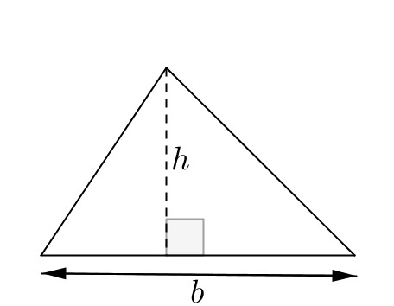  Formula: |   10m  12m
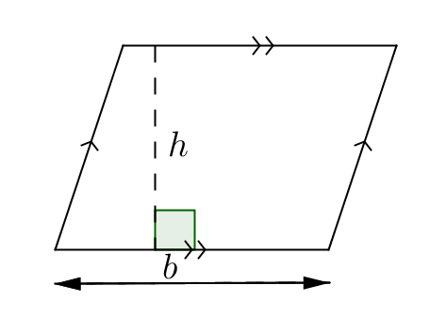  Formula: |   5m  6m
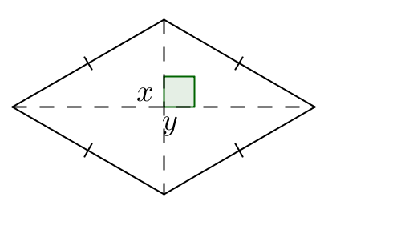  Formula: |   6m  5m
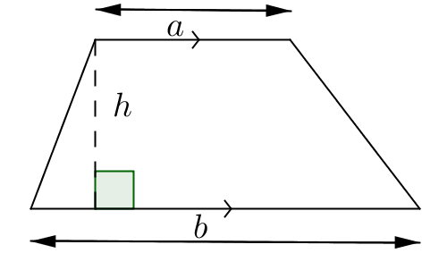  Formula: |   8m  4m  5m
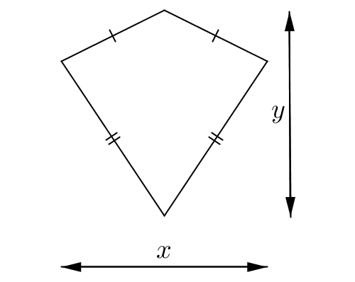  Formula: |   10m  8m
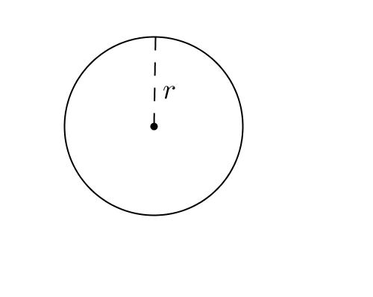  Formula: |   6cm
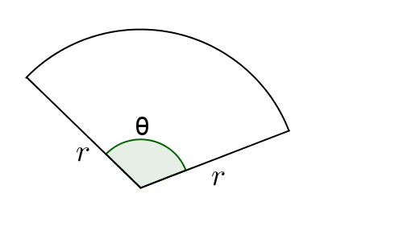  Formula: |   100$°$  6cm

